CS4402 Discussion Assignment

When it comes to web development, choosing the right programming language is crucial. Two prominent contenders in the world of web development are PHP and JavaScript. I would like to dive into a comparison between these two languages, focusing on their performance, portability, functionality, adoption, and their respective strengths in various application areas.

**Summarized in below Table:**

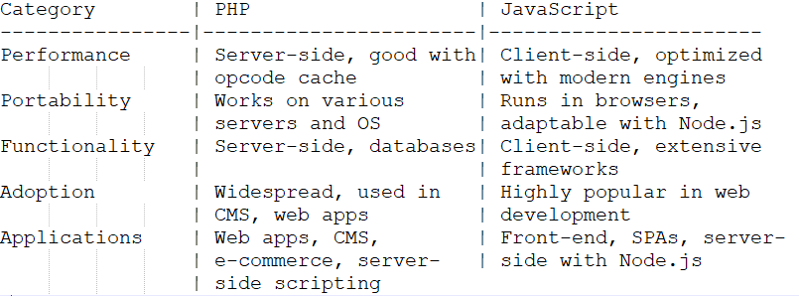

According to (*PHP vs JavaScript: When to Use - Code Institute Global*, n.d.),

**Performance:**

*PHP*: PHP is primarily a server-side scripting language. It processes code on the server and delivers the resulting HTML to the client. However, PHP might not match JavaScript's speed in client-side operations(*PHP vs Node Js - Which Programs Are Fastest?*, n.d.).

*JavaScript*: JavaScript is designed for client-side scripting, and it runs directly in web browsers. With advancements in JavaScript engines like V8, it has become highly performant, making it ideal for interactive web applications.

**Portability:**

*PHP*: PHP is known for its portability, as it can run on various web servers and operating systems. It is often associated with the LAMP (Linux, Apache, MySQL, PHP) stack but is adaptable to different environments.

*JavaScript*: JavaScript is inherently portable since it runs in web browsers across different platforms. It is also used on the server-side with technologies like Node.js, further enhancing its versatility.

**Functionality:**

*PHP*: PHP is excellent for server-side web development. It seamlessly integrates with HTML and databases, making it ideal for dynamic web content, form handling, and server-side logic. It also supports desktop applications.

*JavaScript*: JavaScript shines on the client-side, enabling dynamic and interactive web interfaces. It is used for front-end development and can be extended to server-side scripting with Node.js. JavaScript is complemented by numerous frameworks like AngularJS, ReactJS, and NodeJS, which enhance its functionality.

**Adoption:**

*PHP*: PHP has a massive user base and enjoys widespread adoption in web development. It powers popular content management systems (CMS) like WordPress and is used in various web applications.

*JavaScript*: JavaScript is one of the most widely used programming languages globally, thanks to its role in web development. It has a vast developer community and is the foundation of many modern web applications.

**Application Areas:**

*PHP*: PHP is best suited for developing web applications, content management systems (CMS), e-commerce platforms, and server-side scripting. It excels in handling server-side logic and database interactions.

*JavaScript*: JavaScript is ideal for front-end web development, creating responsive user interfaces, single-page applications (SPAs), and server-side applications when used with Node.js. It's versatile and widely used for web and mobile app development.

In summary, PHP and JavaScript serve different purposes in web development. PHP is well-suited for server-side tasks, while JavaScript shines on the client-side. Your choice between the two should depend on your project's specific requirements and your desired application area. Additionally, combining both languages can harness the strengths of each to create robust and dynamic web applications.

**Reference**

*PHP vs JavaScript: When to Use - Code Institute Global*. (n.d.). Retrieved October 8, 2023, from https://codeinstitute.net/global/blog/php-vs-javascript/

*PHP vs Node js - Which programs are fastest?* (n.d.). Retrieved October 8, 2023, from https://benchmarksgame-team.pages.debian.net/benchmarksgame/fastest/php.html